Done: 4,5, 6, 7, 8, 9, 11, 12, 13, 14, 15, 17, 18, 21

4, 9, 14)Diaphragm pressure seal, flanged, threaded, socket welded, or welded. Diaphragm chemical seal, flanged, threaded, socket welded, or welded. Also Two-way on-off solenoid valve. (In 9th with Generic instrument connection to process line)

3, 20) Drainage or drain unit of a pipeline system

5) Filled thermal element capillary tube. Filled sensing line between pressure seal and instrument.

6) Primary Choice or Basic Process Control ­System: Located in field.­ Not panel, cabinet, or console mounted. Visible at field location. Normally operator accessible. (PDIT - Pressure Differential Indicating Transmittor)

7) Primary Choice or Basic Process Control ­System: Located in or on front of central or main panel or console. Visible on front of panel or on video display. Normally operator accessible at panel front or console. (PDI - Pressure Differential Indicating )

8)PG - Pressure Gauge

10) Drain valve

12) Generic pressure safety valve. Pressure relief valve. Also additional Reducers (Concentrics) and Spring or weight actuated relief or safety valve actuator at the end.

13)PSV - Pressure Save Valve

16)F-123 A - Regeneration Waste Filter

11,15,17,18) Generic instrument connection to process line.Generic instrument connection to equipment.

19) Two-way on-off solenoid valve.

21) Drain



Diaphragm pressure seal, flanged, threaded, socket welded, or welded. Diaphragm chemical seal, flanged, threaded, socket welded, or welded.

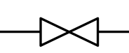

Two-way on-off solenoid valve.



Spring or weight actuated relief or safety valve actuator.

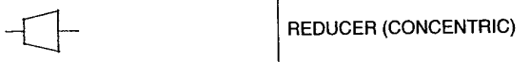

Reducer (Concentric)